# Deployment on Flask

Build and Deploy a car price prediction Machine Learning Model on Flask

Muhammed KURNASAN

16/04/2022

# Import Data

The first move is to import a data to train a model

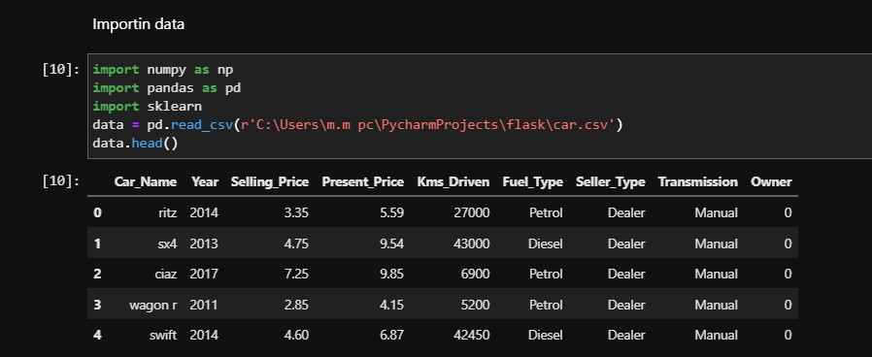

# Sorting the data

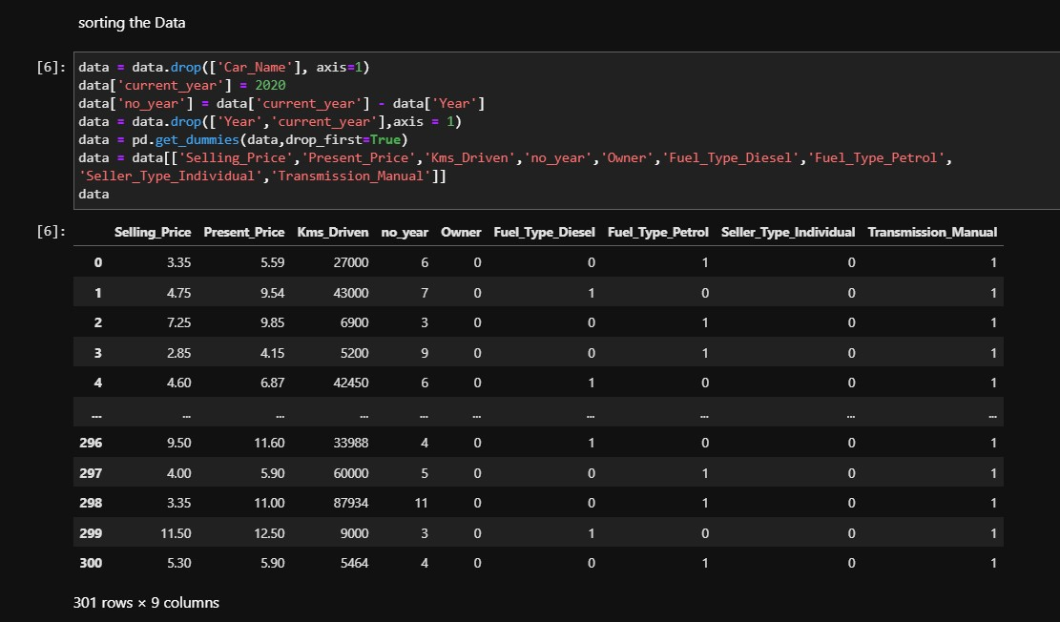

## Remove the correlated features

The data. corr() will give you an intuition on the correlation between all attributes in the dataset. More correlated features can be removed since they can lead to overfitting of the model.

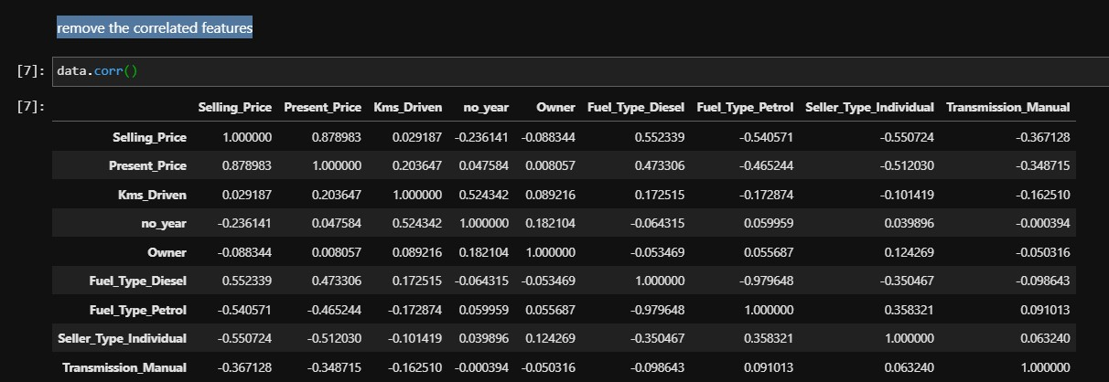

Slicing the data into training and test set and remove the less important features from the data.

The extratressregressor library allows you to view feature importances and thereby remove the less important features from the data.

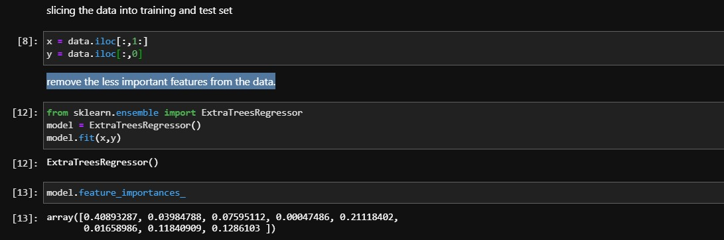

## Train Test Split and Training the model

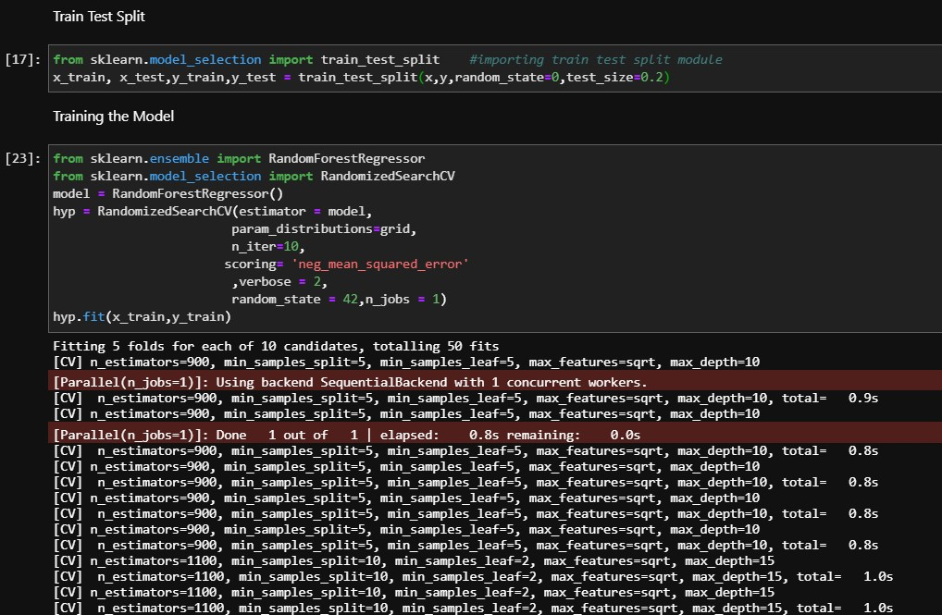

finally use the model to predict the test dataset and Pack the model into the pickle file

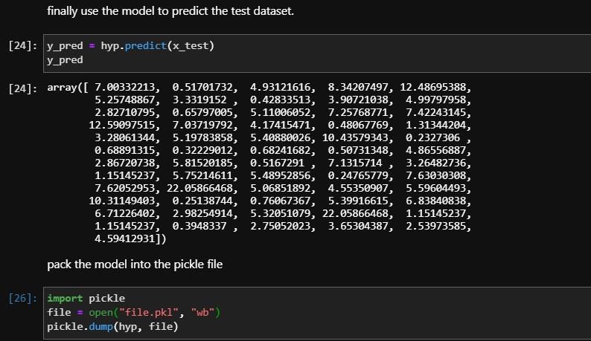

### Deploy the model on flask

Seting up a Flask project and loading the trained model

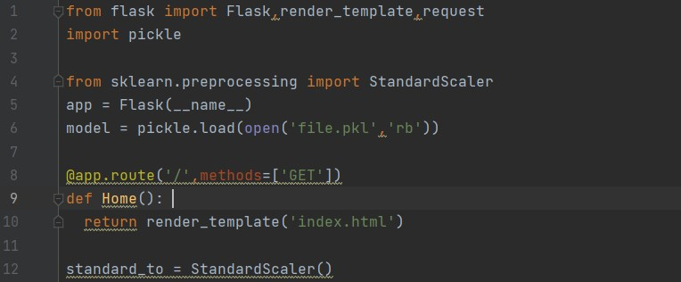

Deploy the model on flask

Finishing

up

the

predict

method

to

predict

the

car

price

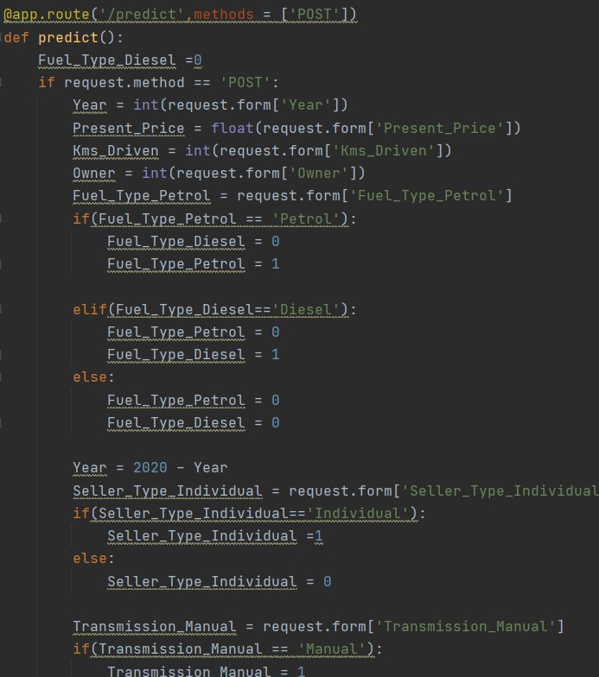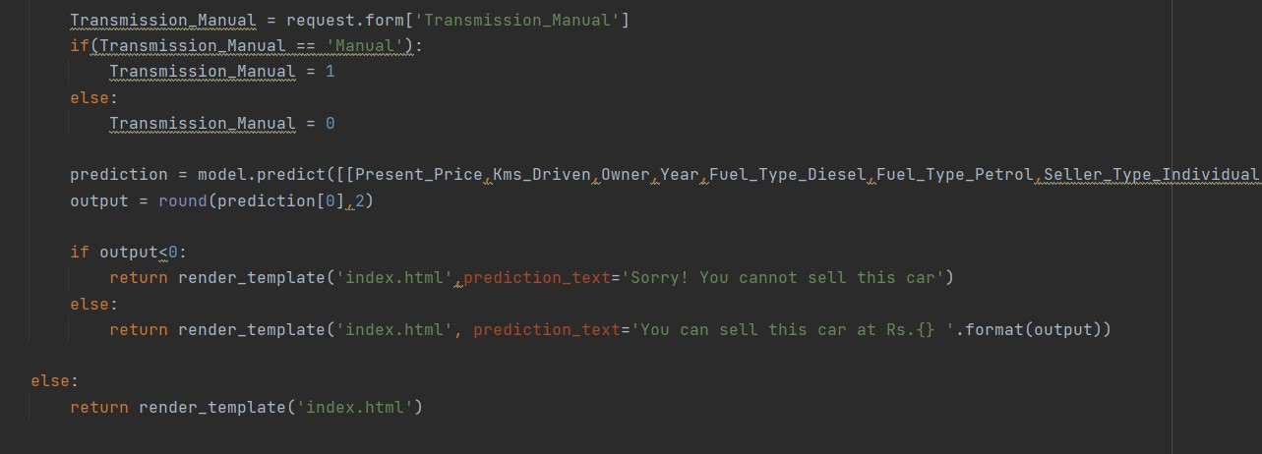

### Deploy the model on flask

Finishing up the HTML code 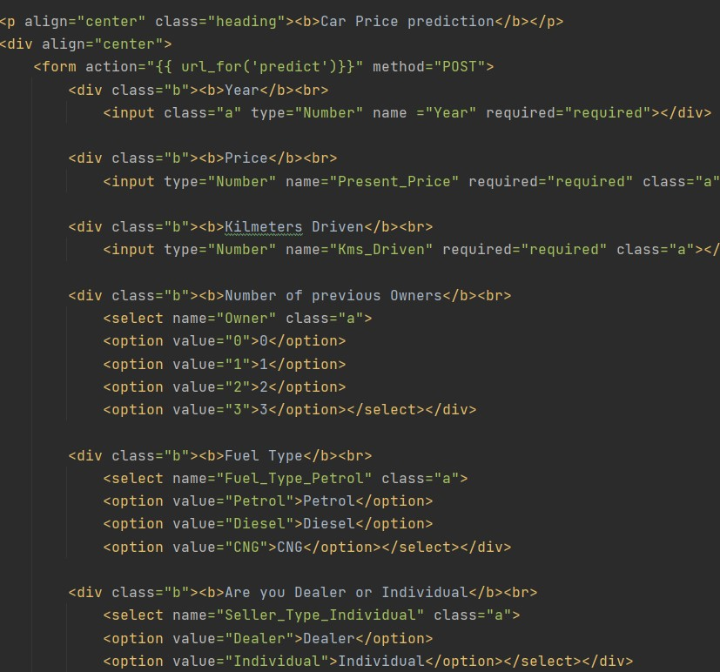

### The result

### Prediction example

